**Eagle Pixel Streaming Feature Template**

This template demonstrates how to communicate UE4 app to Player Page and back while using Eagle Streaming System.

The Pixel Streaming Plugin that runs within the Unreal Engine exposes a Blueprint API that you can use in your gameplay logic to handle custom UI events sent by the player HTML page, and to emit events from the Unreal Engine to the player page.

To access this Blueprint API, add the **Pixel Streamer Input** to the Player Controller of your project with Pixel Streaming Plugin enabled for your project.

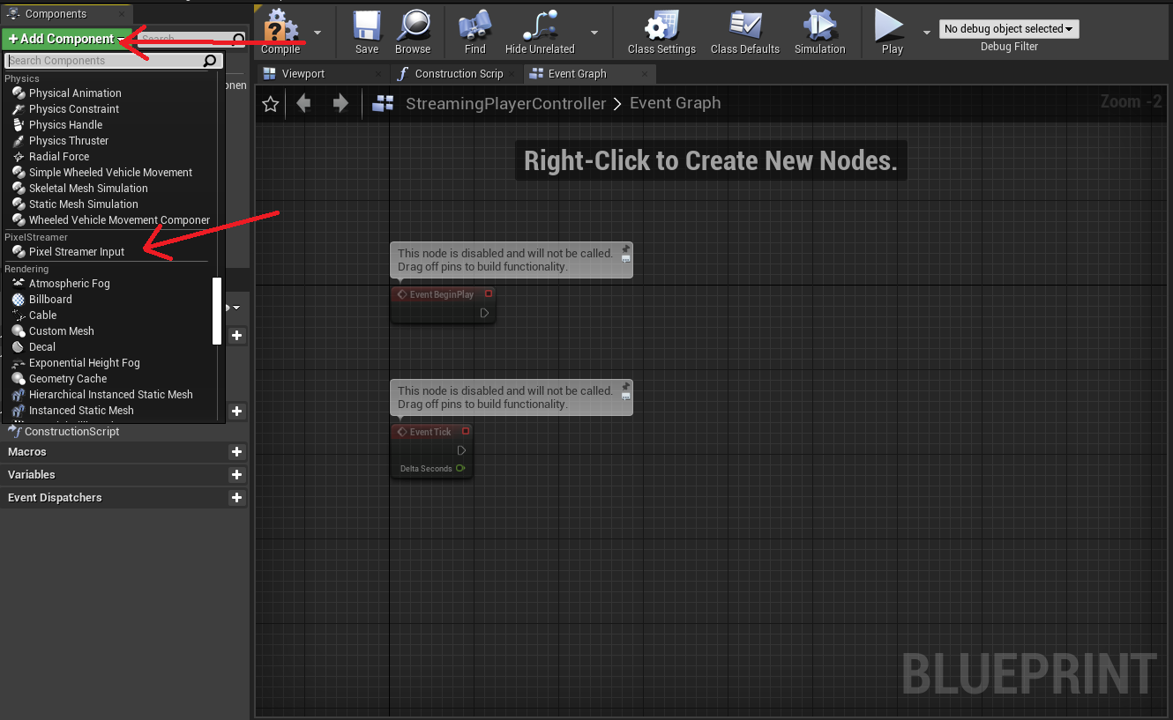

**BP_DemoDisplay Blueprint:**Path: Content\DemoRoom\BluePrint

You can retrieve it from the Player Controller using the **Actor > Get Component by Class** node. Click the **Component Class** input, and look for the **PixelStreamingInputComponent** in the list. **Pixel Streaming Response String** is a public variable which will be set for each instance of the **BP_DemoDisplay** differently in the map for the demonstration purpose.

In the demo Send Pixel Streaming Response function is attached to the 3d Button press in map, however this can also be attached to any **Key Press**, other **Custom Events** and **UMG events**.

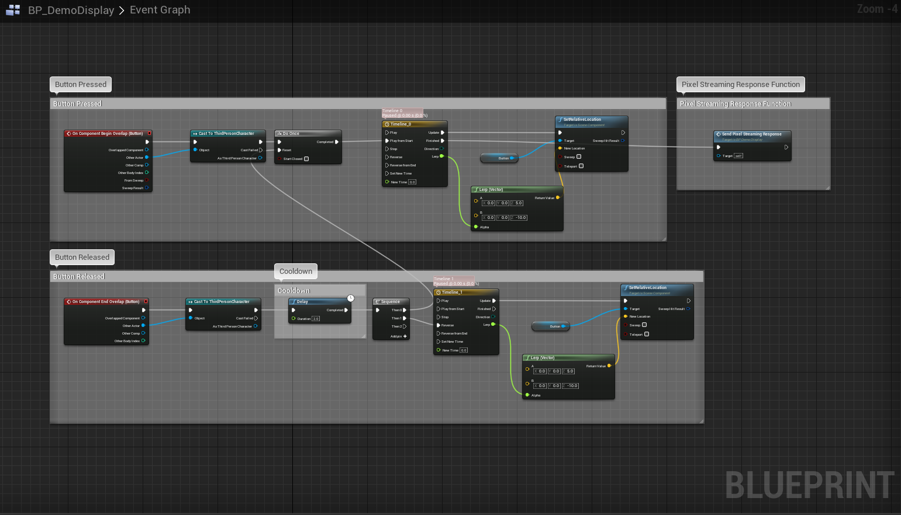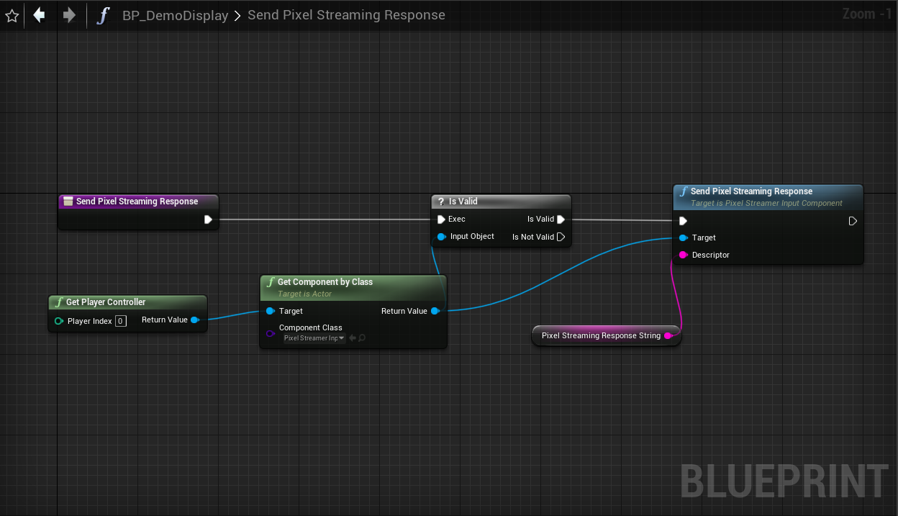

**Features**

1. **Open URL**

To Open a URL on Pixel Streaming User pass on the JSON object, our system will open a new Tab in the user's browser with the given URL.   
Please note that in some URL there could be special signs which won’t be compatible with this.

Syntex:

{"cmd":"lunchUrl","value":"Put URL Here"}

Example Descriptor:  
 {"cmd":"lunchUrl","value":"<http://www.eagle3dstreaming.com/>"}

Blueprint:   
 /Content/Blueprint/PixelStreamingBP/OpenURL.uasset

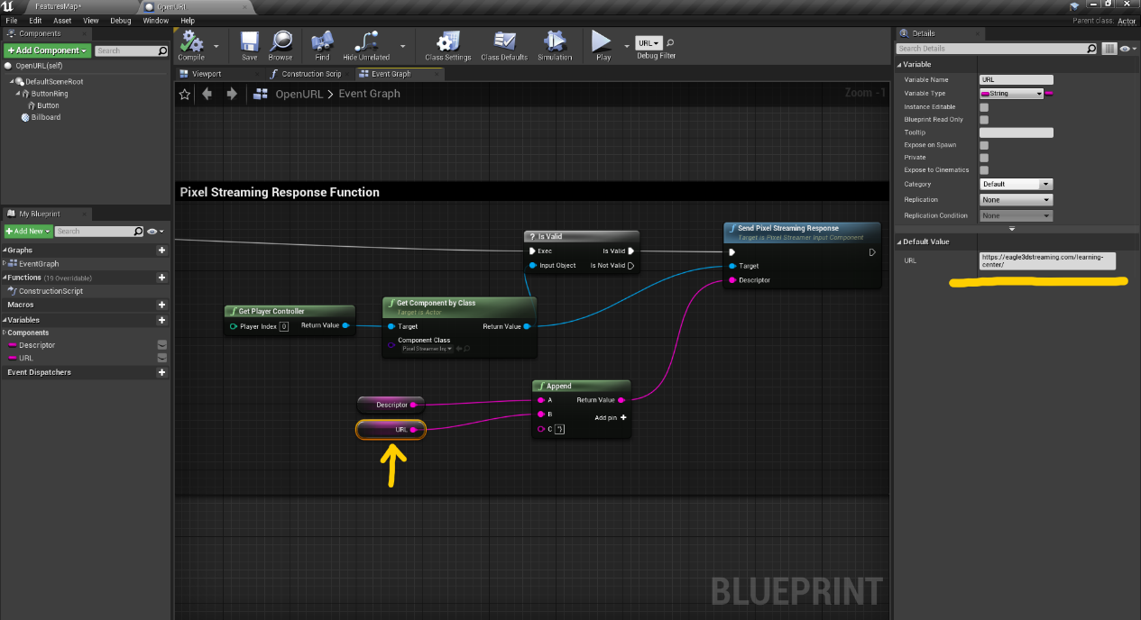

1. **Open Mailing app**

To launch the default mail app on User’s device like Outlook or Gmail.  
Syntex:  
{"cmd":"lunchMailApp","value":"Email to send to"}

Example Descriptor:  
{"cmd":"lunchMailApp","value":"business@eagle3dstreaming.com"}

Blueprint:   
 Content/Blueprint/PixelStreamingBP/LaunchMailApp.uasset

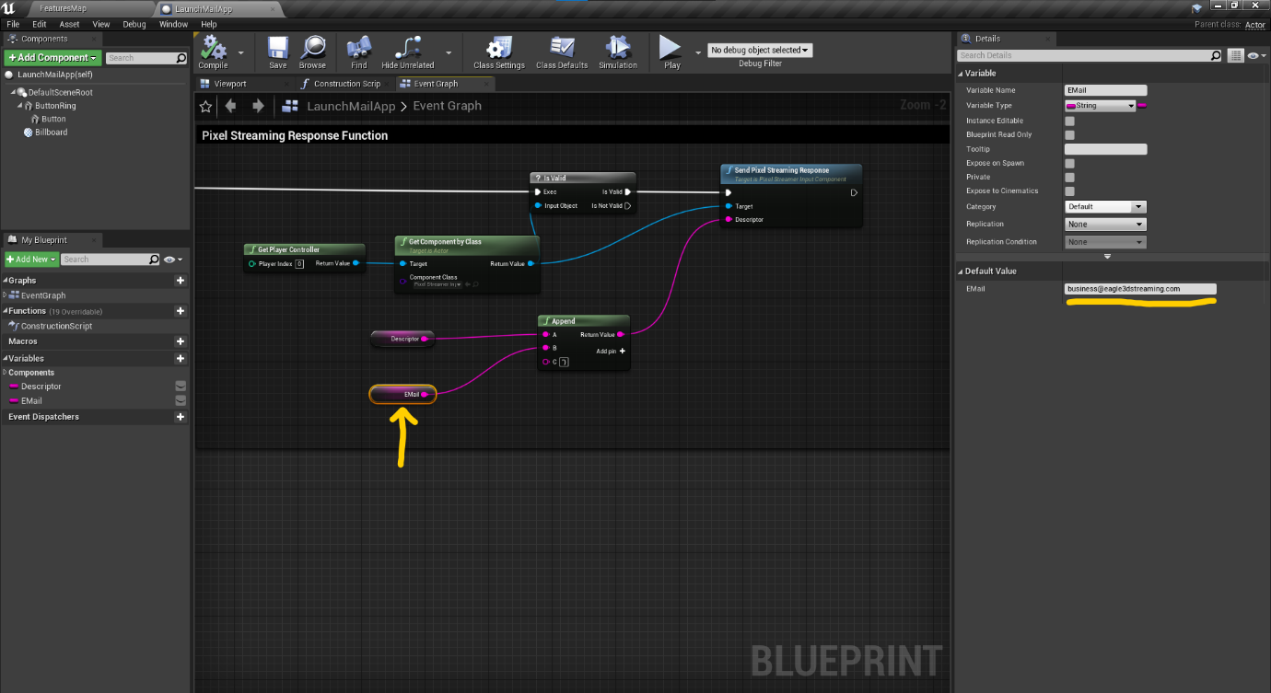

1. **Open Calling App**

To open a calling app with Phone number to call to.  
Syntex:  
{"cmd":"lunchCallApp","value":"Phone Number"}

Example Descriptor:  
{"cmd":"lunchCallApp","value":"(432) 296-2920"}

Blueprint:

Content/Blueprint/PixelStreamingBP/LaunchCallApp.uasset

1. **Keyboard**

Open Keyboard  
Descriptor:  
{"cmd":"lunchKeyBoard"}  
  
Blueprint:  
Content/Blueprint/PixelStreamingBP/OpenKeyBoard.uasset

1. **Mouse Toggle**To toggle the visibility of Browser Mouse.  
     
   Descriptor:

{"cmd":"ToggleBrowserMouse"}  
  
Blueprint:  
Content/Blueprint/PixelStreamingBP/BrowerMouse.uasset

1. **Increase the Pixel Streaming Session**Descriptor:  
   {"cmd":"increaseSessionExpireTime","value":"Amount"}  
     
   Blueprint:  
   Content/Blueprint/PixelStreamingBP/ SetSessionTimer.uasset
2. **Show Information About Pixel Streaming User**This command share the information about the user which is using the Pixel Stream  
   Country Name and City  
     
   Descriptor:  
   {"cmd":"sendUserInfo","value":""}  
   Blueprint:

Content/Blueprint/PixelStreamingBP/GetUserInfo.uasset

1. **Show Information About Pixel Streaming User’s Device**This command share the information about the user’s device on which Pixel Stream is running  
   Operating System on the Device (Windows, IOS, Android)  
   Browser Name  
     
   Descriptor:  
   **{"cmd":"sendUserInfo","value":""}**
2. **Video Player**Demonstrate How to setup Video in Pixel StreamingBlueprint:  
   Content/DemoRoom/BluePrint/TV.uasset
3. **Audio Player**Demonstrate How to setup Audio in Pixel Streaming
4. **Command Line Arguments**Demonstrates how to pass commandLineArguments

In Eagle Pixel Streaming control Panel-  
Edit Config File-

Add command line to be passed in “CmdLineParameters To Pass to App” box.  
  
Another method which system supports is directly adding arguments at the end of URL add ?exeLunchArgs=- and then values  
Example:  
[https://connector.eagle3dstreaming.com/v5/demo/FeaturesTemplate/KunalConfig?exeLunchArgs=-green pink red](https://connector.eagle3dstreaming.com/v5/demo/FeaturesTemplate/KunalConfig?exeLunchArgs=-green%20pink%20red)  
  
You can find more info here in Epic Documentation [Link](https://docs.unrealengine.com/4.27/en-US/ProductionPipelines/CommandLineArguments/).  
  
  
TRY THE DEMO url